**FACULTY OF SCIENCE AND TECHNOLOGY**

**Assignment (Laboratory) Coversheet**

|  |  |
| --- | --- |
| Student ID number | U3312590 |
| Student Name | Jasmine Bajracharya |
| Unit name | Introduction to Computer Engineering |
| Unit number | 10096 |
| Name of lecturer/tutor | Dr. Julio Romero |
| Assignment topic | Inverse Kinematics |
| Due date | 2nd November, 2025 |
| Word Count | 748 |

***You must keep a photocopy or electronic copy of your assignment.***

**Student declaration**

I certify that the attached assignment is my own work. Material drawn from other sources has been appropriately and fully acknowledged as to author/creator, source and other bibliographic details. Such referencing may need to meet unit-specific requirements as to format and style.

I give permission for my assignment to be copied, submitted and retained for the electronic checking of plagiarism.

**Date: 30th October 2025**

(Students submitting work electronically can type their name in the space for signature above, but

must produce a signed copy of this coversheet on request.)

**Date of submission: 30th October 2025**

# **1. Playground Setting Up (30 marks)**

* 1. A4 reference sheet is properly written with XYZ reference system and point of interest.

The initial starting point for the robot arm was taken as the origin that is (x, y, z) as (0,0,25) the z-axis was not considered and was assumed to be zero for the ease of calculations.   
  
The point of interest was plotted at (x, y, z) = (136, 28, 25)   
  
The image of the sheet was obtained as:

* 1. Calculation of joint angles based on the reference and point of interest described above.

Insert calculations here. Use the Student Worksheet provided.

**Measurements:**

|  |  |
| --- | --- |
| **L1 = 120 mm** | **L2 = 150mm** |
| **L3 = 45 mm** | **Ψ = 0** |
| **X =136 mm** | **Z= 25 mm** |
| **y = 28mm** |  |

**Calculations**

|  |  |  |
| --- | --- | --- |
| **Θ0 = a tan2(x, y) = 11.64** | **r = sqrt (x.x+y.y) = 138.83** |  |
| **Wx= r- L3 cosψ = 93.85mm** | **Wz = z – L3.sinψ = 25.0 mm** |  |
| **D = 0.7629 mm** | **|D| ≤ 1 ?** | **No** |
| **Θ2 = atan2(sqrt(1- D.D), D) = 139.72** | **θ1 = −71.80** |  |
| **Θ3 = ψ – (θ1 + θ2) = −67.921** |  |  |

**1.3** Checking correct calculations using the interactive IK checker (optional. No marks awarded).

The calculations were verified using the interactive IK checker and were obtained as:

# **2. Hardware Implementation Robotic Arm (40 marks)**

**2.1** Robot arm is properly set up at zero reference.

Provide joint angles lectures and corresponding XYZ coordinates using both the joystick and the terminal.

The joint angles were set and the robot arm was placed at the zero-reference position with co-ordinates (x, y, z) = (0, 0, 25)

The measurements were taken all in mm.  
The image of the robot arm at the zero-position using joystick and terminal was obtained as:

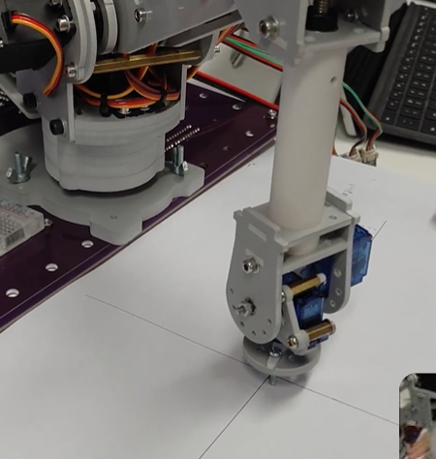

**2.2** Robot arm is properly set up at chosen reference.

Provide joint angles lectures and corresponding XYZ coordinates using both the joystick and the terminal

The joint angles were set, and the robot arm was moved to the corresponding chosen reference with the co-ordinates (x, y, z) = (136, 28, 25)

The image of the robot arm at the reference point is obtained as:

**2.3** State the purpose of the circuit.  
**Answer:** The circuit serves as an interface between the control system, the robot arm and the user input for the robot arm. The main purpose of the circuit is to control the movement of the robot arm so that the robot arm can be moved to the specified position.

# **3. Hardware Implementation Robotic Arm IK (30 marks)**

**3.1** Use the Arduino code provided in part 2 of the tutorial material, and the angle calculations obtained above and verify that the robot reaches the zero-reference point in the A4 sheet. (**30 marks**)

Using the Arduino code of the tutorial material and the joint angles through the terminal of Arduino, the robot arm was reached at the reference point:

**3.2** Use the Arduino code provided in part 2 of the tutorial material, and the angle calculations obtained above to verify that the robot reaches the XYZ reference point in the A4 sheet. [**Bonus: 10 marks**]

Using the code provided in the tutorial material, the robot arm was moved to the set reference point by setting the joint angles through the terminal and the robot am position was obtained as:

\**Note: The videos and the images of the robotic arm can be accessed through the file robot_arm_end_position.*

# **REFERENCES**

[1] Corke, P. (2023). *Robotics, Vision and Control: Fundamental Algorithms in Python* (3rd ed.). Springer Nature.

[2] Corke, P., Jachimczyk, W., & Pilat, R. (2023). *Robotics, Vision & Control: Fundamental Algorithms in MATLAB*